STEP 1: AMAZON

1. It could be beneficial to us as an individual for two reasons, advertising and improving customer experience. For example, when I bought an iPad on Amazon, I find iPad case advertisements on other websites for iPad case advertisement because they know that I just bought an iPad. Another example is since the company knows what the customer demands, the company can offer us new promotions of a certain product which improves customer experience.
2. This also benefits Amazon because it is an easily and efficient method to make the customer to buy the product and it can refine marketing strategy. For example, customers may turn around and change their minds when buying a product to constantly reminding them through email or promotions can change their minds to buy the product. Another example is that it helps companies understand how consumers are engaging with and responding to their marketing campaigns whether or not customers are responding to their emails or advertisements for a specific product.
   1. APA: Uzialko, A. C. (2018, August 3). How and Why Businesses Collect Consumer Data. Retrieved April 15, 2020, from <https://www.businessnewsdaily.com/10625-businesses-collecting-data.html>
3. This could be negative because an individual would not want their privacy known to others and the feeling of being tracked down creates an insecure feeling in the user’s mind.
4. 4 Big Data components:
   1. Volume: It is the scale of data, how large is the data collected. For amazon the larger the volume of data it is better for the because they have less uncertainty of providing the customer the wrong promotion, for example.
   2. Variety: The different forms of data collected. The different forms of data can be differentiated into Facebook contents, YouTube videos, Google searches, and etc. This also relates to Amazon because they track all the variety of data that the customer searches for. Amazon can use this variety of data to identify accurately what the customer demands.
   3. Veracity: The uncertainty of data collected. Uncertainty always exists in a bigdata search because it is quite hard to make sure what the customer demands accurately. Thus, the volume and variety of bigdata reduces the uncertainty. In Amazon the veracity of bigdata might cause customers to report advertisements when they do not want those products.
   4. Velocity: The analysis of streaming data. Before presenting an advertisement to the customers, there has to be an analysis of the streamed data by the customers. Amazon also does this by tracking down customer searches in the customer’s browser.

STEP 2B:

1. I searched the words: World, Poverty, Economy. These words are related to the world poverty and how the economy of people/countries are related to the help or harm to poverty.
2. 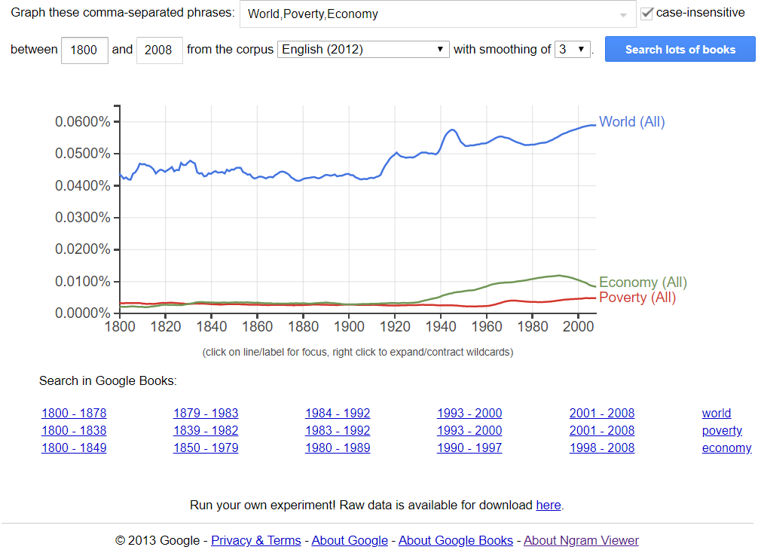
3. Objective:
   1. World: This word has shown a relatively increasing popularity over time. It did change over time unstably, but it has increased when seen in a linear line. The word has increase during the 1920 – 2000.
   2. Poverty: This word has shown a constant popularity over time. It did change overall but in a very slight movement. The popularity of this word has increased slightly in the 1960 – 2000.
   3. Economy: This word’s popularity is increasing overtime. The popularity has changed but not in a back and forth manner, it increased 1930 – 1990 and decreased in the 2000s.
4. Subjective:
   1. I think that some words are more popular than others because some words are used in other many different situations, where others are not. The frequency of the words we use increases the popularity of the words. Words like “World” can be use in subjects like World pollution but words like “Poverty” can be only used in the subject poverty.